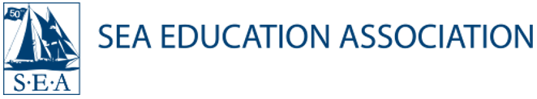

President
Sea Education Association
Woods Hole, MA
Steering a course for the future

The Sea Education Association (SEA), an interdisciplinary and experiential education organization dedicated to studying the oceans, seeks a bold, visionary leader and strategic thinker to serve as its next President. Celebrating its 50th year in 2022, SEA has taken more than 10,000 college, gap year, and high school students on transformative educational journeys of discovery—to explore by tall ship and understand the world’s oceans and maritime environments while simultaneously developing decision-making, team building, communication, and leadership skills. The new President will join the SEA community at a post-pandemic inflection point that brings an opportunity for an innovative and passionate leader to grow the profile and voice of the organization on a national and international scale.

The oceans are threatened by the adverse effects of overfishing, pollution, and global climate change, making SEA’s longstanding mission and real-world impact more important and relevant than ever before. SEA works to inform worldwide marine stewardship and policy and inspire the next generation of ocean scholars, stewards, and leaders through its educational programs, cutting-edge research, and collaborative partnerships. This is an exciting and unique opportunity to lead an organization with global impact, and to do so on an intimate scale amid a culture that prioritizes collaboration and teamwork.

Reporting to the Board of Trustees, the President serves as the chief executive officer and will be responsible for providing transformative leadership to promote SEA’s mission and vision while vastly expanding the scope and impact of the organization’s research, outreach, and innovative programming at sea aboard tall ships, on shore, and online. The next President will elevate SEA’s profile locally, nationally, and globally within the oceanographic and academic communities and the public at large to diversify its revenue streams and ensure that SEA is structured and resourced for long-term financial and organizational sustainability. The successful candidate will provide the support and resources needed to retain its dedicated faculty and staff of approximately 100; continue to advance SEA’s dedication to diversity, equity, and inclusion (DEI); and ensure the organization’s human and fiscal resources are well managed. The President needs to be able to navigate the space where scientists, scholars, educators, advocates, and policy makers interact to make positive change for the future of the oceans.

Sea Education Association has retained Isaacson, Miller, a national executive search firm, to assist in this important recruitment. Nominations, inquiries, and applications (CVs and letters of interest) should be submitted online in confidence to:

Elizabeth Dorr Weithman, Managing Associate
Amy Gillespie, Associate
Isaacson, Miller
https://www.imsearch.com/search-detail/8615
263 Summer Street, 7th Floor Boston, MA 02210

SEA is an equal opportunity employer and strongly encourages applications from people of color, persons with disabilities, women, and LGBTQ+ candidates. SEA is committed to the development of a multicultural environment and values input of multiple viewpoints and perspectives across the organization; its goal is to create an academic and working community that is rich with cultural, social, and intellectual diversity.

